Collected data

Authors:
TEDyBEAR Center: Jacqueline NADEL
CNRS-LIMSI: Tom GIRAUD, Brian RAVENET, Jean-Claude MARTIN

This project was carried out within the framework of the MIMETIC project.
"Software for training combined with collaborative social interaction and motor learning in Autism Spectrum Disorder".
This project is a winner of the Call for Autism and New Technologies projects, coordinated by FIRAH and supported by the Orange Foundation and the UEFA Children's Foundation.
Work done by:
TEDyBEAR and LIMSI-CNRS

The project was supported by: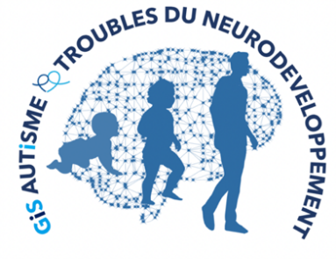

Web sites:
https://mimetic.limsi.fr/

https://www.firah.org/fr/logiciel-pour-l-entrainement-combine-a-l-interaction-sociale-cooperative-et-a-l-apprentissage-moteur.html

The FIRAH is a Foundation recognized as a public utility, which wishes to put research at the service of actors in the field. It is chaired by Patrick Gohet.
It is to meet the needs and expectations of people with disabilities that FIRAH was founded and that it develops today around these activities:
- Support applied research projects on disability.
- To stimulate the valorization of the results of this research in particular with the actors in the field.
- Animate the dissemination of knowledge on disability produced throughout the world.
http://www.firah.org

Tedybear

Tedybear is a group of experimental medical-social centers dedicated to the education of young children with Autism Spectrum Disorder (ASD) between the ages of 3 and 11, most of whom are non-verbal. These centers are approved by the ARS d'Ile de France. One is located in Saint-Cloud, the other more recent one is in Paris. TEDyBEAR has developed an innovative pedagogical concept based on inclusive education and coordination with family and caregivers.
With the objective of school inclusion: Sharing of time between the school and the center; Coordination with the school: participation in the ESS, GEVASCO, implementation of liaison notebooks, visits to the center by teachers and AVS, and by liberal therapists (speech therapist, psychomotricist, occupational therapist).
In the objective of coordination with the family: Educational booklet given out each weekend with weekly sheet from the referring psychologist, monthly curves of positive and negative behaviors; weekly sheet from the educators providing information on autonomy and social adaptation to peers; daily relay table to the families showing clips of the day; In return, weekly sheet filled out by the parents and providing information on behavior at home during the week.
Tedybear works in 1/2/3: one child for a psychologist during the therapies, 2 children for a psychologist for the pedagogical activities, 3 children for an educator for the activities relaying with the school in the field of socialization.
The pedagogical work is of the neuro-educational type with the social brain exercise as a base. A particular focus is placed on imitation, which is central to development in that it is closely related to major functions, perception, action, language, and is the initial support for communication and learning. Therapies are of two types: imitation to develop non-verbal communication and observational learning, and kinect to develop body awareness and calibration of spatial organization.

LIMSI-CNRS (www.limsi.fr, BP 133, 91403 Orsay).

The Laboratory of Computer Science for Mechanics and Engineering Sciences is a multidisciplinary research laboratory that brings together researchers from different disciplines of Engineering and Information Sciences as well as Life Sciences and Social and Human Sciences. Administratively, the LIMSI is a CNRS unit, attached to the Institute of Information Sciences and their Interactions of the CNRS.
Research in human-computer interaction is interested on the one hand in analyzing, understanding and modeling the interactions between humans and artificial systems. The CPU group involved in this project focuses on the psychology of non-verbal and collective affective interactions in humans as well as on the design of affective and virtual human-computer interfaces. The members of the group are teacher-researchers from the University Paris-Saclay in Computer Science, Human-Computer Interaction and Psychology.
Several projects concern the training of social skills for (children, adolescents and adults; with or without pathology) such as the design of virtual characters for training job interviews or training of health care staff using virtual patients. Researchers participate in the definition of theoretical frameworks, the design of human-computer interactions and their experimental evaluation.

Summary

I. Introduction 5
II. Motion data automatically recorded by the platform 5
III. Motion data visualization software 6
IV. Appendix 1: Examples of motion data automatically recorded by the MIMETIC system 7
V. Appendix 2: How the platform records log files 9

Introduction

This deliverable was produced as part of the MIMETIC project "Software for training combined with cooperative social interaction and motor learning".
This deliverable is intended in particular for professionals with certain technical skills who wish to have explanations on how the MIMETIC platform records data on the movements performed by children during joint action training sessions.
This report describes the interaction data collected during the project in sessions with the children and illustrates their visualization with a dedicated program.
Other types of data collected are described in other deliverables:
- Parents' answers to the questionnaire ("02 Needs Study" deliverable)
- Movies describing motor actions ("06 Collaborative Motor Actions Library" deliverable)
Finally, we remind you that it is not possible to provide films of children interacting with the device for reasons of privacy protection.

Motion data automatically recorded by the platform

The data does not include any personal data identifying the participating children, which is represented by an anonymous identifier.
The collected data is available upon request by email to MARTIN@LIMSI.FR.

The collected data is provided in an .xls file that has one tab per child with all the information stored for all training sessions that have taken place with that child. Each session includes information for the scenarios (also called exercises) performed during that session.

Each tab contains the following data for the same child:
- Session date: date and time of the beginning of the session
- Active Audio
- Height child (m): size of the child (which was used to set the size of the virtual agent)
- Agent: the virtual agent with which the child has interacted: Lola or Michou
- Speed (m/s): Speed of movement
- Distance lag (m)
- Height shelf (m) / Shelf height
- Nb scenario: number of scenarios/exercises performed and recorded during the session
- And for each scenario, a line with the following information
  - Result: Result for the year: SUCCESS or FAILED or ABORTED
  - Object taken : the object that has been taken by the child : BOX or TABLE or CHAIR
  - Duration(s): duration of the scenario
  - FrameRate (frame/s)
  - Nb segment of mvt: number of segments of the movement
  - Max speed (m/s): Maximum speed during the scenario
  - Normalized jerk score (no unit) :
  - Mean distance with Agent (m): average distance between the trajectory followed by the child and the trajectory followed by the virtual agent (more precisely the trajectory of the tangible part of the object and the trajectory of the virtual part of the object).
  - Std distance with Agent (m)
  - Lag of best lagged correlation (s)
  - Best lagged correlation on Speed (no unit)

An example is provided in Appendix 1.
The procedure for recording data is described in Appendix 2.

Motion data visualisation software

In order to facilitate the use of the movement data collected during the sessions with the children, visualization software was developed as part of the project.

Appendix 1: Examples of motion data automatically recorded by the MIMETIC system

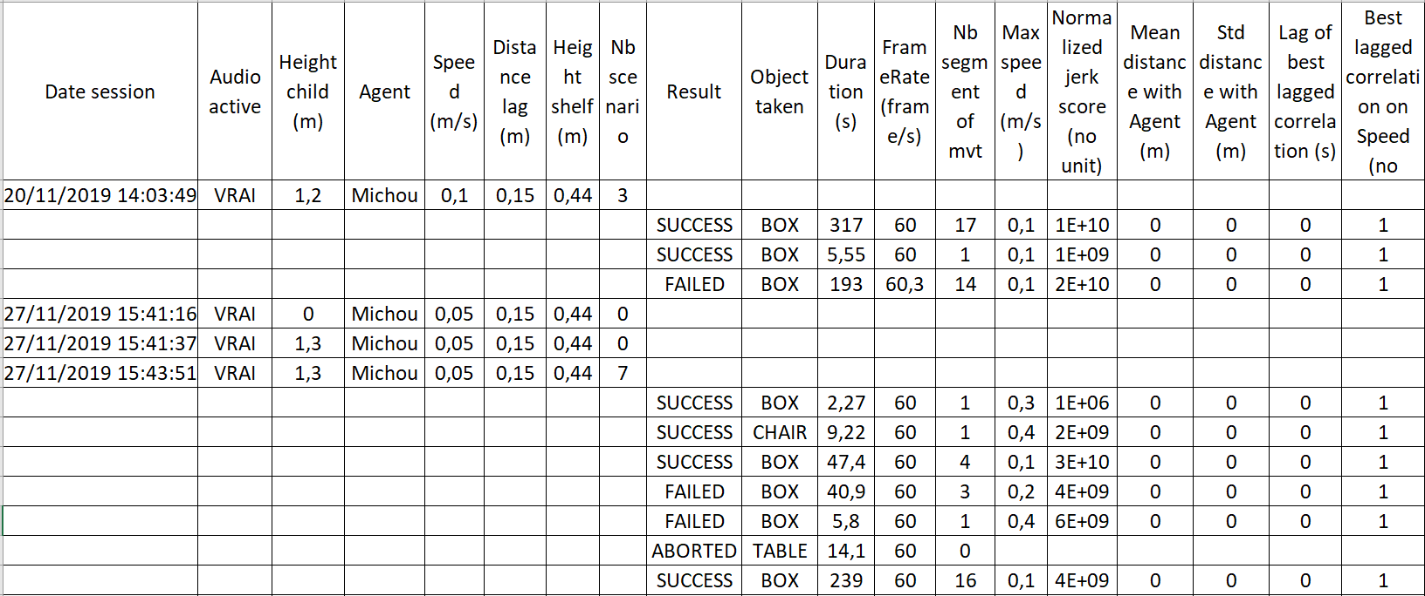
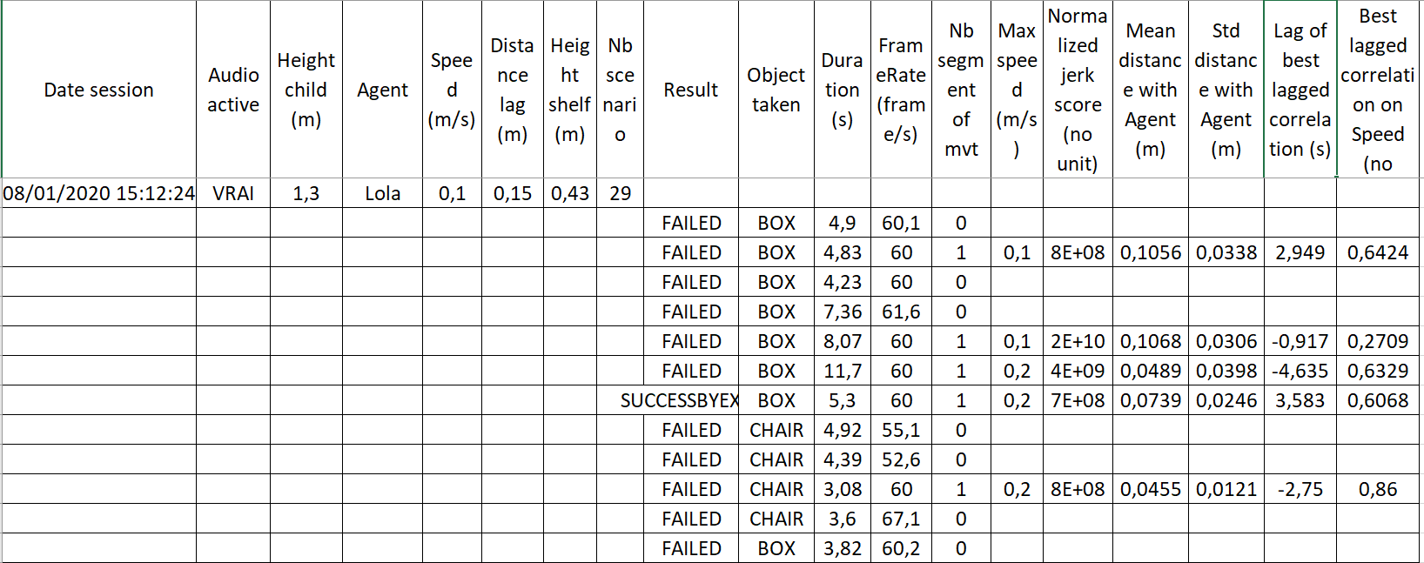

Appendix 2: How the platform records log files

A session is considered to be launched when the system displays one of the two virtual characters (Lola or Michou) waiting for an order.
As soon as a session is launched, a first file is created containing the session configuration ("session details"). The session is identified in the file name by the date and the participant ID, for example: "7_9_2019_9h3m22s636_ID_1_sessiondetails.txt".

Then, as soon as a task is entered by the operator using the digital box (for example "Put the box on the table"), a file is created for this task. A file is created for each task.
This file in csv (Comma Separated Value) format, which is identified by the session date, the participant id, a task id and the result of this task ("Success" or "Failure"), contains all the movements of each of the objects in the system, their real version detected by the mouse and the webcam, and their virtual version held by the virtual character.

A directory is generated, its name is designed from the current date and the ID entered by the operator in the application interface (on the home screen).
In this directory, a text file with the tag sessiondetails is generated for each configuration (here the configuration for lola AND the configuration for michou, so 2),
Then, for each of the configurations, 4 csv files are generated, one for each instruction (8 in total). This makes a total of 10 files in 1 directory.

