Outreach and communications
Authors:
TEDyBEAR Center: Jacqueline NADEL
LIMSI-CNRS: Jean-Claude MARTIN

This report was produced within the framework of the MIMETIC project.
"Software for training combined with collaborative social interaction and motor learning in Autism Spectrum Disorder".
This project is a winner of the Call for Autism and New Technologies projects, coordinated by FIRAH and supported by the Orange Foundation and the UEFA Children's Foundation.
Work carried out by:
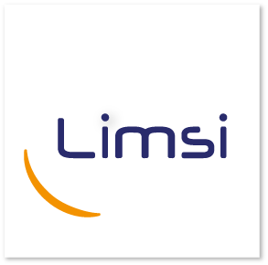
TEDyBEAR and LIMSI-CNRS
The project was supported by: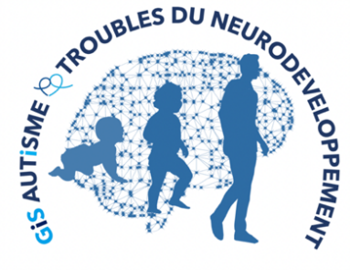
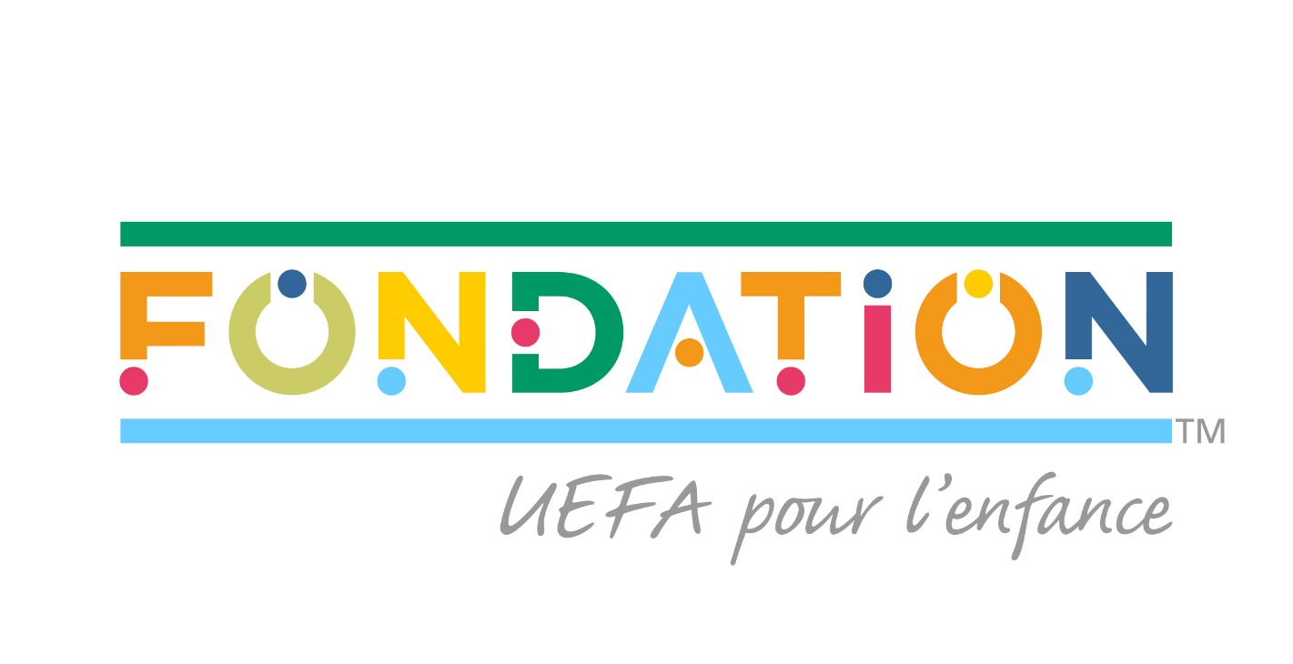
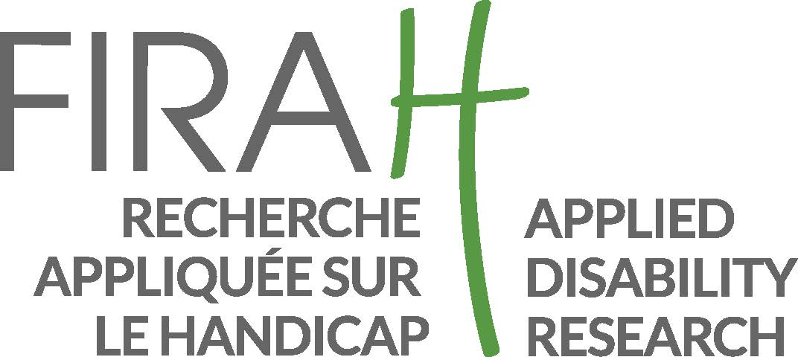

Web sites:
https://mimetic.limsi.fr/

https://www.firah.org/fr/logiciel-pour-l-entrainement-combine-a-l-interaction-sociale-cooperative-et-a-l-apprentissage-moteur.html

The FIRAH is a Foundation recognized as a public utility, which wishes to put research at the service of actors in the field. It is chaired by Patrick Gohet.
It is to meet the needs and expectations of people with disabilities that FIRAH was founded and that it develops today around these activities:
- Support applied research projects on disability.
- To stimulate the valorization of the results of this research in particular with the actors in the field.
- Animate the dissemination of knowledge on disability produced throughout the world.
http://www.firah.org

Tedybear

Tedybear is a group of experimental medical-social centers dedicated to the education of young children with Autism Spectrum Disorder (ASD) between the ages of 3 and 11, most of whom are non-verbal. These centers are approved by the ARS d'Ile de France. One is located in Saint-Cloud, the other more recent one is in Paris. TEDyBEAR has developed an innovative pedagogical concept based on inclusive education and coordination with family and caregivers.
With the objective of school inclusion: Sharing of time between the school and the center; Coordination with the school: participation in the ESS, GEVASCO, implementation of liaison notebooks, visits to the center by teachers and AVS, and by liberal therapists (speech therapist, psychomotricist, occupational therapist).
In the objective of coordination with the family: Educational booklet given out each weekend with weekly sheet from the referring psychologist, monthly curves of positive and negative behaviors; weekly sheet from the educators providing information on autonomy and social adaptation to peers; daily relay table to the families showing clips of the day; In return, weekly sheet filled out by the parents and providing information on behavior at home during the week.
Tedybear works in 1/2/3: one child for a psychologist during the therapies, 2 children for a psychologist for the pedagogical activities, 3 children for an educator for the activities relaying with the school in the field of socialization.
The pedagogical work is of the neuro-educational type with the social brain exercise as a base. A particular focus is placed on imitation, which is central to development in that it is closely related to major functions, perception, action, language, and is the initial support for communication and learning. Therapies are of two types: imitation to develop non-verbal communication and observational learning, and Kinect to develop body awareness and calibration of spatial organization.

LIMSI-CNRS (www.limsi.fr, BP 133, 91403 Orsay).

The Laboratory of Computer Science for Mechanics and Engineering Sciences is a multidisciplinary research laboratory that brings together researchers from different disciplines of Engineering and Information Sciences as well as Life Sciences and Social and Human Sciences. Administratively, the LIMSI is a CNRS unit, attached to the Institute of Information Sciences and their Interactions of the CNRS.
Research in human-computer interaction is interested on the one hand in analyzing, understanding and modeling the interactions between humans and artificial systems. The CPU group involved in this project focuses on the psychology of non-verbal and collective affective interactions in humans as well as on the design of affective and virtual human-computer interfaces. The members of the group are teacher-researchers from the University Paris-Saclay in Computer Science, Human-Computer Interaction and Psychology.
Several projects concern the training of social skills for (children, adolescents and adults; with or without pathology) such as the design of virtual characters for training job interviews or training of health care staff using virtual patients. Researchers participate in the definition of theoretical frameworks, the design of human-computer interactions and their experimental evaluation.

Outline

Introduction 5
Communication actions 5
Oral communications (in reverse chronological order) in 2021 5
Oral communications (in reverse chronological order) in 2020 5
Oral communications (in reverse chronological order) in 2019 7
Events cancelled due to the health crisis and where communications were planned 7
Other communications 7
Scientific articles and communications 10
Extension actions and planned communications and in preparation 10

Introduction

This deliverable was produced as part of the MIMETIC project "Software for training combined with cooperative social interaction and motor learning".
This deliverable is intended for all those who wish to learn more about the project and more generally about the use of joint action training with children with Autism Spectrum Disorder.
This report lists the actions of communications around the project.
Due to the health crisis, several events, particularly for the general public, have been cancelled or postponed.

Communication actions

The MIMETIC project was described or mentioned in the following communication events:

Oral communications (in reverse chronological order) in 2021
- February 17th 2021. Video presentation « Can you help me move this over there?": training children with ASD to joint action through tangible interaction and virtual agent", 15th ACM International Conference on Tangible, Embedded and Embodied Interaction (TEI’2021) https://tei.acm.org/2021/”.

Oral communications (in reverse chronological order) in 2020
- December ^{1st,} 2020. "Multimodal Social Interactions for Training and Coaching", invited presentation at the Seminar "Perception and Human-Robot Interaction" of the Working Group WG5 "Human-Robot Interactions of the GDR Robotics".
- September 25, 2020. Colloquium IA and Autism, organized by the Société de Psychiatrie Française, Rennes. Contribution by Jacqueline Nadel ' The challenge of mental codes in virtual presentations '.
- September 8, 2020. École supérieure des technologies industrielles avancées (ESTIA), Biarritz. Presentation by Jean-Claude Martin and Tom Giraud.
- June 2, 2020. Workshop on Positive Technologies for Learning. Video-conference presentation by Jean-Claude Martin. 8th Meeting of Young Researchers in EIAH (Computer Environments for Human Learning). https://edutechwiki.unige.ch/fmediawiki/index.php?title=Les_technologies_positives_pour_l%27apprentissage

Oral communications (in reverse chronological order) in 2019
- November 28, 2019. Two presentations by Jean-Claude Martin at the Nara Institute of Science and Technology (NAIST): 1) "Social Computing: Considering Self and Others for Coaching and Social Skills Training" to the Master students, 2) researchers of the French-Japanese ANR TAPAS project.
- November 22, 2019. Roundtable "Putting AI at the service of the inclusive school" organized by #Leplus at EducaTICE . Presentation by Jacqueline Nadel: The role of virtual technologies in the inclusion of non-verbal children with autism spectrum disorder.
- October 2, 2019. University of Augsburg, Germany. Presentation by Jean-Claude Martin and Tom Giraud.
- September 18, 2019. Symposium "Technologies for Autism: What works? "organized by O. Grynszpan . Campus Sorbonne University. Presentation by Jacqueline Nadel: "Digital techniques for the non-selective benefit of Autism Spectrum Disorder. »

Events cancelled due to the health crisis and where communications were planned

- TEDyBEAR 2020 Open House (cancelled): The open house includes a reception for siblings and was intended to be an opportunity to introduce the platform to siblings and parents. Unfortunately, the confinement forced us to cancel them and since then we have welcomed no one in our premises other than professionals and children.
- Séminaire 11 March 2020. Social goes digital - modern assistance systems (AAL) in the care of people with support needs. Holzen Monastery. Présentation par Elisabeth André.

Other communications
- The MIMETIC platform is installed at the TEDyBEAR Center at Porte d'Italie in Paris.
At Saint-Cloud, although the center does not have the platform, we have set up scenarios modelled on those of the platform (see our action library) and it works very well.
A document has been sent to parents to explain the objective of the project: to get the children to collaborate. They were also given a questionnaire asking them if they saw any progress with our systematic exercises.
In any case, at the center, it's obvious and it's generalized to help the little ones get dressed, for example.
- TEDyBEAR Newsletter n°1 of September 2020: announcement of the takeover of the MIMETIC platform:
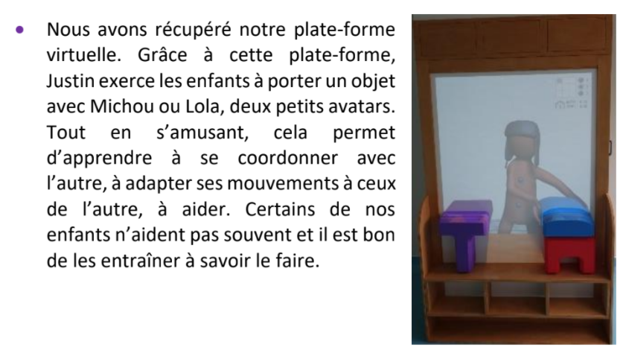
- TEDyBEAR Center Facebook page:

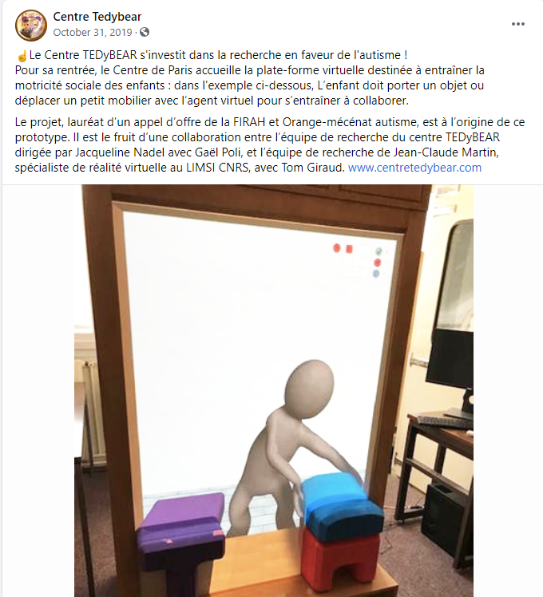

Scientific articles and communications

- Nadel, J. Co-coordination with L. Vandromme of the thematic issue of Enfance 1, 2018: "New technologies for the benefit of autism". 175 pages
- Martin, J.-C. (2018) Virtual agents for learning social skills in autism: a review. Enfance 2018/1 (No. 1), pages 13 to 30. https://www.cairn.info/revue-enfance-2018-1-page-13.htm
- Nadel, J. & Poli, G. (2018). Evaluating and training body awareness in autism via Kinet and Pictogram Room, Enfance 2018/1 (No. 1), pages 51 to 64 https://www.cairn.info/revue-enfance-2018-1-page-51.htm
- Nadel, J., Grynszpan, O., Martin, J.-C. (à paraître) Autism and Socially Interactive Agents. ACM handbook on Socially Interactive Agents.
- Nadel, J. (2021). Imitate to grow (3rd edition fully updated with the addition of a chapter on New Technologies and Imitation). Paris: Dunod.
- Giraud Tom, Ravenet Brian, Tang Chi-Tai, Nadel Jacqueline , Prigent Elise, Poli Gael, André Elisabeth, Martin Jean Claude (accepted) Design of virtual and tangible interactions to teach motor collaboration to children with Autism Spectrum Disorder. Paper accepted at the 32nd Francophone Conference on Human-Computer Interaction scheduled in Metz from April 13 to 16, 2021 https://ihm2020.afihm.org/fr/?accueil
- « Can you help me move this over there?": training children with ASD to joint action through tangible interaction and virtual agent", article accepté à la 15ème ACM International Conference on Tangible, Embedded and Embodied Interaction https://tei.acm.org/2021/ (taux d'acceptation 30%, conférence en ligne)

Planned communications and in preparation

- ARAPI Newsletter: Nadel, J., Martin, J.-C. (accepted, 2021) Development of a virtual and tangible platform for motor collaboration in autism.
- CNRS Journal
- LIMSI Tweeter account
- Days postponed to 2021 due to sanitary conditions
  - World Autism Awareness Day
  - May 11, 2021 : ARAPI Day : " Autism and new technologies " organized by C. Queromes and C. Queromes. Tijus. Presentation of the MIMETIC platform by Jacqueline Nadel.
  - Université d'Automne de l'ARAPI scheduled from 04 to 08 October 2021 in Port aux Rocs (Le Croisic). https://site.arapi-autisme.fr/2020/01/07/universite-dautomne-de-larapi/ Training workshop "Imitation" led by Jacqueline Nadel scheduled for 8 October 2021.

